INDIVIDUAL SCHEDULES OF OJTs

Practicum 1 2nd Sem AY 2016-2017 TeamMC

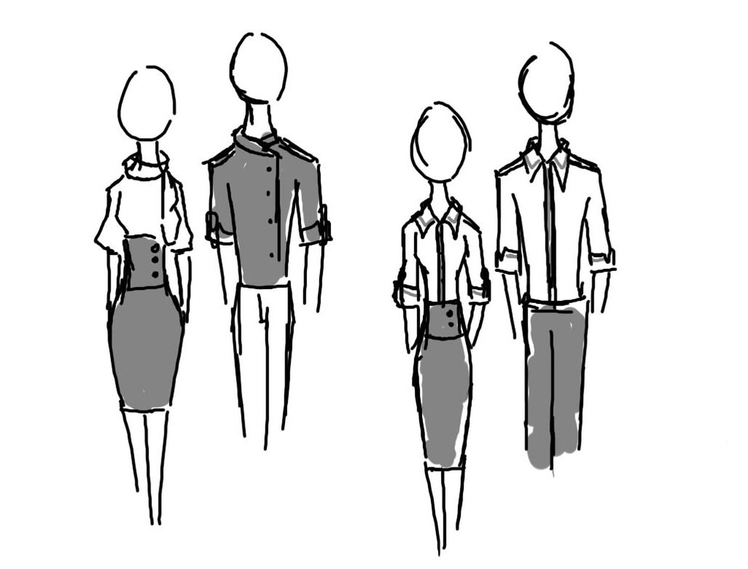

**ABALOS, Joshua James A.**

**Corpo Days:** Monday, Wednesday, Friday

**FRIDAY**

**TIME:** 10:30 – 12:00 NN

**ROOM:** Knowledge Center

**TIME:** 3:00 – 5:00 PM

**ROOM:** S422

**THURSDAY**

**TIME:** 9:00 – 10:30 AM

**ROOM**: Knowledge Center

**TIME:** 2:30 – 4:00 PM

**ROOM**: S421

**MONDAY**

**TIME:** 9:30 – 11:30 AM

**ROOM:** S422

**TIME:** 2:30 – 4:00 PM

**ROOM:** S422

**TUESDAY**

**TIME:** 3:00 – 6:00 PM

**ROOM:** S422

**WEDNESDAY**

**TIME:** 9:30 -11:30 AM

**ROOM:** S422

**TIME:** 4:00 -6:00 PM

**ROOM:** Knowledge Center

**ADVERSALO, Aeneid Anthony M.**

**Corpo Days:** Tuesday, Wednesday, Saturday

**THURSDAY**

**TIME:** 9:30 – 12:00 NN

**ROOM:** Knowledge Center

**TIME:** 2:30 – 4:00 PM

**ROOM:** S421

**FRIDAY**

**TIME:** 3:00 – 5:00 PM

**ROOM:** S422

**WEDNESDAY**

**TIME:** 9:30 – 11:30 AM

**ROOM:** S422

**TIME:** 4:00 PM – 5:30 PM

**ROOM:** Knowledge Center

**TUESDAY**

**TIME:** 10:30 – 12:00 NN

**ROOM:** Knowledge Center

**TIME:** 3:00 – 4:30 PM

**ROOM:** S422

**MONDAY**

**TIME:** 2:30 – 4:00 PM

**ROOM:** S421

**TIME:** 5:30 – 7:00 PM

**ROOM:** S422

**ANTERO, Randy Ezekiel Jr.**

**Corpo Days:** Monday, Thursday, Friday

**THURSDAY**

**TIME:** 2:30 – 4:00 PM

**ROOM:** S421

**TIME: 5**:30 – 7:00 PM

**ROOM:** S422

**FRIDAY**

**TIME:** 3:00 – 6:00 PM

**ROOM:** S422

**WEDNESDAY**

**TIME:** 9:30 – 11:30 AM

**ROOM:** S422

**TIME:** 4:00 PM – 6:00 PM

**ROOM:** S421

**TUESDAY**

**TIME:** 3:00 – 5:00 PM

**ROOM:** S422

**MONDAY**

**TIME:** 9:30 – 11:30 AM

**ROOM:** S422

**TIME:** 2:30 – 4:00 PM

**ROOM:** S422

**ARBOLENTE, Kathleen Dianne A.**

**Corpo Days:** Everyday

**THURSDAY**

**TIME:** 9:00 – 10:30 AM

**ROOM:**

**TIME:** 2:30 – 4:00 PM

**ROOM:** S421

**FRIDAY**

**TIME:** 10:30 – 12:00 NN

**ROOM:** S422

**TIME:** 3:00 – 6:00 PM

**ROOM:** S422

**WEDNESDAY**

**TIME:** 4:00 – 6:00 PM

**ROOM:** S421

**TUESDAY**

**TIME:** 3:00 – 6:00 PM

**ROOM:** S422

**MONDAY**

**TIME:** 9:30 – 12:00 NN

**ROOM:** S422

**TIME:** 2:30 – 4:00 PM

**ROOM:** S422

**CABALSE, Ariane Faye E.**

**Corpo Days:** Tuesday, Wednesday, Thursday

**WEDNESDAY**

**TIME:** 1:00 – 5:00 PM

**ROOM:** S422

**THURSDAY**

**TIME:** 9:00 – 11:00 AM

**ROOM:** Knowledge Center

**TIME:** 4:00 – 11:00 AM

**ROOM:** S422

**FRIDAY**

**TIME:** 4:30 – 5:30 AM

**ROOM:** S422

**TUESDAY**

**TIME:** 1:00 – 5:00 PM

**ROOM:** S422

**MONDAY**

**TIME:** 4:00 – 6:00 PM

**ROOM:** S422

**JARAMEL, Kenneth D.**

**Corpo Days:** Monday, Thursday, Friday

**WEDNESDAY**

**TIME:** 8:30 – 10:30 AM

**ROOM:** S422

**THURSDAY**

**TIME:** 8:30 – 10:30 AM

**ROOM:** Knowledge Center

**FRIDAY**

**TIME:** 3:30 – 5:30 PM

**ROOM:** S422

**TUESDAY**

**TIME:** 3:00 – 6:00 PM

**ROOM:** S422

**MONDAY**

**TIME:** 9:30 – 12:00 NN

**ROOM:** S422

**TIME:** 2:30 – 4:00 PM

**ROOM:** S422

**CAYABYAB, Emarie A.**

**Corpo Days:** Tuesday, Friday, Saturday



**WEDNESDAY**

**TIME:** 9:30 – 11:30 AM

**ROOM:** S422

**TUESDAY**

**TIME:** 3:00-5:00 PM

**ROOM:** S422

**MONDAY**

**TIME:** 9:30 – 11:30 AM

**ROOM:** S422 10:30 – 11:30

**TIME:** 2:30 – 4:00 PM

**ROOM:** S422

**FRIDAY**

**TIME:** 3:00 – 5:00 PM

**ROOM:** S422

**THURSDAY**

**TIME:** 8:30 – 11:30 AM

**ROOM:** Knowledge Center

**MACANLALAY, Abigail A.**

**Corpo Days:** Everyday

**WEDNESDAY**

**TIME:** 4:00 – 7:00 PM

**ROOM:** S421 4:00-7:00

**TUESDAY**

**TIME:** 4:00 –7:00 PM

**ROOM:** S422 5:30-7:00

**MONDAY**

**TIME:** 9:30 – 12:00 AM

**ROOM:** S422 10:30-12:00

**TIME:** 4:00 – 5:30 PM

**ROOM:** Knowledge Center

**THURSDAY**

**TIME:** 9:00 – 11:00 AM

**ROOM:** Knowledge Center

**TIME:** 4:00 – 6:0) PM

**ROOM:** S422

**FRIDAY**

**TIME:** 7:30 – 9:30 AM

**ROOM:** S326

**MANGAYA, Keane S.**

**Corpo Days:** Monday, Wednesday, Friday

**WEDNESDAY**

**TIME:** 7:30 – 9:30 AM

**ROOM:** S422

**TUESDAY**

**TIME: 7**:30 –9:00 AM

**ROOM:** S326 7:30-9:00

**TIME:** 1:30 –4:00 PM

**ROOM:**S421

**MONDAY**

**TIME:** 4:00 – 7:00 PM

**ROOM:** S422

**THURSDAY**

**TIME:** 7:30 – 9:00 AM

**ROOM:**Knowledge Center

**TIME:** 1:30 – 4:00 PM

**ROOM:** S421

**FRIDAY**

**TIME:** 4:00 – 6:00 PM

**ROOM:** S422

**MORILLO, Rey Mark**

**Corpo Days:** Monday, Wednesday, Thursday

**MONDAY**

**TIME:** 4:00 – 7:00 PM

**ROOM:** S422

**WEDNESDAY**

**TIME:** 4:00 – 7:00 PM

**ROOM:** S421

**TUESDAY**

**TIME:** 2:30 –4:00 PM

**ROOM:** S422



**FRIDAY**

**TIME:** 8:30– 11:30 AM

**ROOM:** Knowledge Center

**THURSDAY**

**TIME:** 3:00 – 6:00 PM

**ROOM:** S422

**CALIMLIM, Nathaniel John A.**

**Corpo Days:** Monday, Friday, Saturday

**WEDNESDAY**

**TIME:** 4:00 – 6:00 PM

**ROOM:** S421

**TUESDAY**

**TIME:** 9:00 – 10:30 PM

**ROOM:** Knowledge Center

**TIME:** 3:00 – 5:30 PM

**ROOM:** S422

**MONDAY**

**TIME:** 9:00 – 11:30 AM

**ROOM:** S422



**FRIDAY**

**TIME:** 8:30– 11:30 AM

**ROOM:** Knowledge Center

**THURSDAY**

**TIME:** 8:30 – 11:30 PM

**ROOM:** Knowledge Center

**TIME:** 3:00 – 6:00 PM

**ROOM:** S422

**DERIJE, Franchesca Bernadeth C.**

**Corpo Days:** Monday, Wednesday, Thursday

**TUESDAY**

**TIME:** 8:00 – 12:00 PM

**ROOM:** S422

**TIME:** 2:30 – 4:00 PM

**ROOM:** S422

**TUESDAY**

**TIME IN:** 5:00 - 7:00 PM **ROOM:** S422

**WEDNESDAY**

**TIME:** 8:30 – 12:00 PM

**ROOM:** S422



**THURSDAY**

**TIME:** 8:00 – 10:30 PM

**ROOM:** Knowledge Center

**TIME:** 2:30 – 4:00 PM

**ROOM:** S422

**FRIDAY**

**TIME:** 10:30– 12:00 AM

**ROOM:** Knowledge Center